TEMPORAL VARIATIONS IN SUBLIMATION AND THEIR RELATION WITH RIDGE FORMATION IN MARTIAN MID-LATITUDE ICE SCARPS. L. S. Perez-Mancipe¹, A. M. Bramson² and K. L. Laferriere³, ¹Universidad de los Andes, Bogotá, Colombia (ls.perez2@uniandes.edu.co), ²Purdue University, West Lafayette, IN (bramsona@purdue.edu), ³University of Central Florida, Orlando , Fl (kris.laferriere@ucf.edu).

Introduction: The mid-latitude regions of Mars have abundant evidence for the presence of water in the form of shallowly buried ice deposits. These ice sheets undergo both accumulation and sublimation, two factors which vary over time in response to changes in Mars’ orbital parameters (orbital forcing). As these ice sheets sublimate and retreat, they form scarps (cliffs that mark the boundary of the remaining ice). These scarps, consist of a surface layer of lag covering the ice, with additional regolith accumulating at their base. As the scarp retreats, ridge structures form parallel to it, likely representing periods of slower sublimation, while intervening depressions or "valleys" correspond to episodes of rapid ice loss [1].
These exposure sites often exhibit a "roughly triangular appearance, where the pole-facing scarp is one edge of the triangle, and two other edges are facing slightly east and west" [2], as shown in figure 1. This morphology and orientation (poleward with slopes of ~45º) suggest that sublimation initiates at a localized point, after which the scarp retreats in a relatively linear way, resulting in a face that is nearly perpendicular to the direction of retreat. 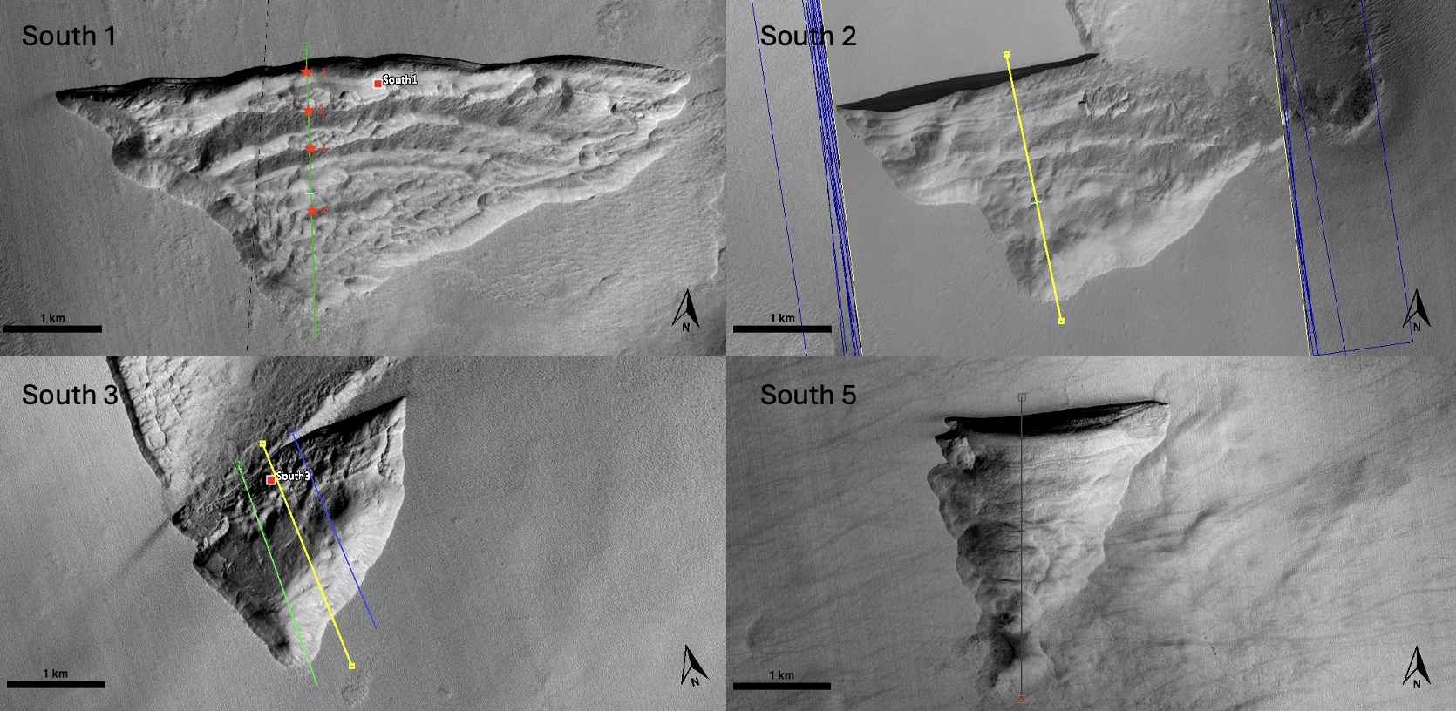
Figure 1: Icy scarps of the southern hemisphere. South 1: upper left, -56.6°N 114°E. South 2; upper right, -55.1°N 109.4°E. South 3: lower left, -58.3°N 93.7°E. South 5: lower right, -57.2°N 89.8°E.
We aim to test this hypothesis to understand how orbital forcing affects the geomorphology of these icy
scarp sites, and investigate if variable retreat rates is a plausible explanation for the observed ridges. To address this, we aim to characterize and compare ridge morphologies—such as number and spacing—across scarps in both hemispheres; and quantify the relationship between obliquity-driven sublimation cycles and ridge formation.
Thermal model: We used a 1D semi-implicit thermal conduction model that simulates the energy balance at the Martian surface and the heat transfer between numerical subsurface layers, given by the Clausius-Clapeyron equation and ideal gas law.
The model resolves heat transfer between the surface and discretized subsurface layers and accounts for radiative exchange and phase changes of surface CO₂. Surface temperatures are regulated by CO₂ frost formation when conditions reach saturation, with frost stability governed by the Clausius–Clapeyron relation. The model was applied to a steep mid-latitude scarps (South 1, 2 and 5) using present-day topography and extended over the last 20 Mya by incorporating time-varying orbital and axial parameters. Cumulative horizontal sublimation is used to quantify ice loss, and temporal transitions in sublimation regimes are identified through inflection points in its derivative.
We reduced the time range (past 0.5 Mya) to be able to cover only the extension of the scarp’s retreat. With the topographic profiles of each scarp (taken from HiRISE images), we qualitatively associated the ridges to the periods of slow sublimation.
Discussion: According to the extension of the scarps (of approximately 2.5-3km), their retreat has been going only for the past 0.5 Mya, meaning that the effect of variations in eccentricity and longitude of perihelion possibly play a bigger role the variations of sublimation rate, that lead to the formation of the ridges found in the scarp sites. All three scarp sites (South 1, 2 and 5) have similar behavior.
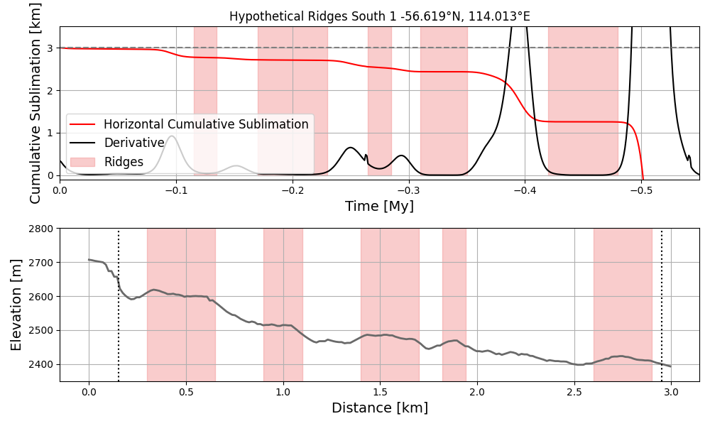
Figure 2: South 1 comparison between the horizontal cumulative sublimation plot (upper plot) along the extension of the scarp site that shows its derivative and its inflection points highlighted, with the topographic profile (lower plot) with the visible ridges highlighted.
Figures 2, 3 and 4 show the horizontal cumulative sublimation plots over the past half million years with the low sublimation periods highlighted and their topographic profiles with the ridges highlighted. We find that the modeled total cumulative retreat reaches 3 km in the last 500,000 years. This places an approximate age on scarp formation and retreat initiation. This age is younger than the 2.4 Mya age suggested by previous studies [2] that assume a constant retreat rate over time.

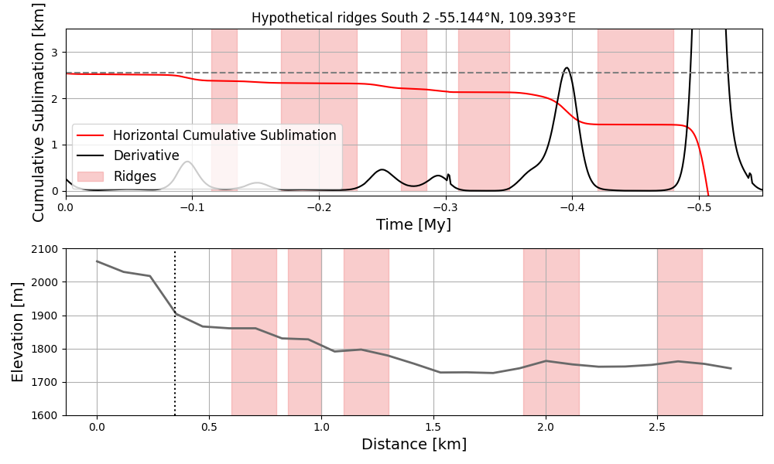
Figure 3: South 2 comparison between the horizontal cumulative sublimation plot (upper plot) along the extension of the scarp site that shows its derivative and its inflection points highlighted, with the topographic profile (lower plot) with the visible ridges highlighted).
The inflection points in the cumulative sublimation plots correspond to periods that the scarp would have limited sublimation, which we hypothesized as being periods of ridge formation. The fact that we also observe Scarp 1 and 2 to have 5 ridges provides evidence in favor of this hypothesis. If our interpretation of ridges corresponding to periods of low sublimation is correct, our results therefore could allow us to place ages on the individual ridges. However, we must consider that the ridges in the other scarp sites are diffuse and some of them are not constant horizontally along the site. Possibly due to erosion processes.

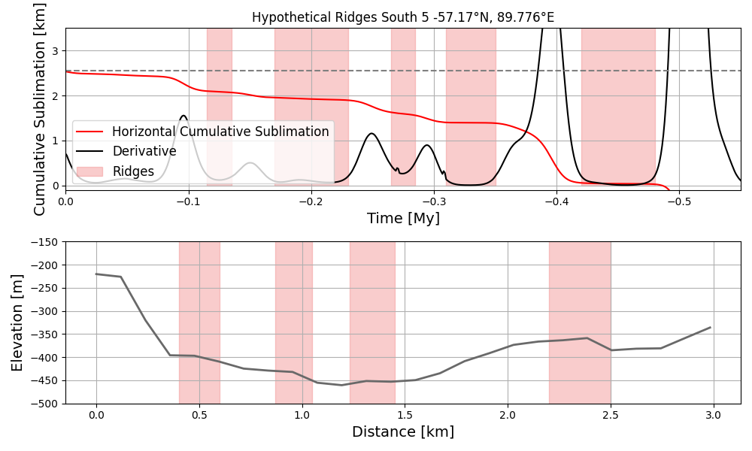
Figure 4: South 5 comparison between the horizontal cumulative sublimation plot (upper plot) along the extension of the scarp site that shows its derivative and its inflection points highlighted, with the topographic profile (lower plot) with the visible ridges highlighted.
We are looking forward into quantitatively relating these ridges to their possible ages given by the low sublimation rate periods, to be able to confirm our hypothesis.

References: [1] Dundas, C. M., Bramson, A. M., Ojha, L., Wray, J. J., Mellon, M. T., Byrne, S., McEwen, A. S., Putzig, N. E., Viola, D., Sutton, S., et al. (2018). Exposed subsurface ice sheets in the martian mid-latitudes. Science, 359(6372):199–201. [2] Williams, K., Dundas, C., and Kahre, M. (2022). The formation mechanisms for mid-latitude ice scarps on mars. Icarus, 386:115174. [3] Author G. H. (2021) LPSC 2023, Abstract #1504. [4] Author I. J. et al. (2009) In Europa (Pappalardo et al., eds.), pp. 485–505, Univ. of Arizona.

